Software Requirements Specification
for
‘Scrumptious’ - Personal Finance website
Version 2.0 approved
Prepared by:
Scrumptious six
2nd March 2018
Table of Contents
Table of Contents ii
Revision History ii
1. Introduction 1
1.1 Purpose 1
1.2 Intended Audience and Reading Suggestions 1
1.3 Product Scope 2
2. Overall Description 2
2.1 Product Perspective 2
2.2 Product Functions 2
2.3 User Classes and Characteristics 2
2.4 Operating Environment 3
2.5 Design and Implementation Constraints 3
2.6 User Documentation 3
2.7 Assumptions and Dependencies 3
3. External Interface Requirements 4
3.1 User Interfaces 4
3.2 Software Interfaces 4
3.3 Communications Interfaces 4
4. System Features 4
4.1 Secure account creation and login 4
4.2 Connecting users financial accounts to website platform 5
4.1.1 Description and Priority 5
4.3 System Feature 5
5. Other Nonfunctional Requirements 6
5.1 Performance Requirements 6
5.2 Security Requirements 6
5.3 Software Quality Attributes 6
5.4 Business Rules 7
6. Other Requirements 7
7. Appendix A: Analysis Models 7
7.1 Sequence diagram 7
7.2 Register User Sequence Diagram 8
7.3 Activity Diagram 9
7.4 UML Class Diagram 10
7.5 Use Case Diagram 11
8. Appendix C: To Be Determined List 12

Revision History
Name | Date | Reason For Changes | Version
‘Scrumptious Personal Finance website’ | 9th February | New version developed | 1.0

Introduction

Purpose
This document serves as a comprehensive documentation for the ‘Scrumptious’ Personal Finance website. This is the second version of the website so this documentation will include details about the developed requirements and the upcoming ones.

Intended Audience and Reading Suggestions
This document is intended for a variety of reading audiences as it is intended to comprehensively give an outline of the requirements and specifications of the Scrumptious Website. Readers are encouraged to read the document from a ‘natural’ flow i.e. beginning at the introduction and following on to the end of the document. However, there are sections that may be skipped by certain users as they may not be as relevant to them; below is an outline of the most relevant parts of this document for each type of reader. (This is however only a suggestion and certain readers may wish to read the whole document for a comprehensive understanding of the website).

Developers
This set of audience will benefit greatest from reading the entirety of the document as in the case of making any revisions/updates it is important to understand why certain specifications were made and to have an in-depth understanding of the way the website was designed at a high level.

Project Managers
This set of audience will also benefit the most from reading the entirety of the document to understand the rationale behind the design of the website and the overall scope of the website.

Marketing staff
These readers are recommended to read the overall description and system features sections of the document as these will give the most information about the features and uses of the website which will be useful from a marketing perspective. The non-functional requirements page is also recommended for reading particularly the section on security as this is a highly important aspect of the website for advertising to users.

General users
This documentation is not explicitly designed to be read by general users as it is not intended to be a ‘user manual’ nor piece of advertising for the website. Nonetheless an interested user may find it useful to read to understand the overall design of the ‘Scrumptious’ website, for this purpose the overall description followed by the system features and the non-functional requirements should suffice.

Testers
This set of audience are recommended to focus their reading on the overall design, the system features and the non-functional requirements. These sections will give the most pertinent information for testers who can then check to ensure that the website is fully functional and secure.

Documentation Writers
These readers are encouraged to read the entirety of the document to gain a full and comprehensive understanding of the website before beginning to write any form of documentation.

Product Scope
The software specified heir-in is the ‘Scrumptious’ Personal Finance website. The purpose of this website is to simplify the process of managing personal finances giving users a quick and easy way to check their balances and savings, pay bills and manage expenditure. The overarching goal therefore is to ‘ensure that all users can manage their personal finance with simplicity and ease regardless of their chosen financial institution’.
This website is the core business operation of the Scrumptious Ltd group, it is therefore designed with the objective of being easily and quickly scalable as the company grows and to provide a constant and reliable stream of revenue for the company.

Overall Description

Product Perspective
This product was created for the Scrumptious group as a new self-contained product. It therefore has no existing system dependencies. All code was built from scratch and this is still a developing version of the website.

Product Functions
- View balances from a variety of institutions
- View section with income flow
- View section with expenditures
- View breakdown of expenditures (bills, groceries, rent…)
- Section to allow payment of bills

User Classes and Characteristics
The 3 main users that shall use this product will be composed of include: general users, administrators and financial institutions.
The ‘general users’ class is quite general and refers to anyone who uses the website for the general management of their personal finances. This will be people between 16-30 who are either just learning how to manage their finances or have some experience managing their finances.They should have functionality within the website to view their account balances and transactions; send money from one account to another and have contact information to their financial services account.
The Financial account class should have the ability to add and update transactions, provide information on current products/services being offered and offer users financial assistance through the website platform. The users will be the only ones with the ability to view all their transactions and user balances.
The Administrators will have the ability to manage user accounts by resetting passwords and approving significant changes e.g. closing the account or closing an account with a financial institution.

Operating Environment
The software is designed to operate on Google chrome and Mozilla Firefox web browsers at it’s best, though it should also work with other web browsers. It uses the concept of ‘graceful degradation’ to work with web browsers that use older versions of HTML or CSS.
The software is also designed with phone use in mind so that it may also be easily used via a mobile phone ‘on the go’.
The Primary software versions used when designing this project include: HTML5, CSS3.
The database hosting of this project is managed by an external provider.

Design and Implementation Constraints
Due to time and capacity constraints the developers were unable to test the initial version with all screen sizes and phone web browsers. However, a wide variety of devices were used in the testing phase which gives us confidence that the website will be functional on majority of user’s devices.

User Documentation
User help will be a built-in component of the website where uses can easily either search for help with navigating the website or quickly browse through frequently asked questions. Video tutorials will also be made available via a YouTube channel linked to the website to assist users with the website functions and interface, this will be done when the website is ready for release.

Assumptions and Dependencies
As this is a website it will be fully dependent on the versions of CSS and HTML being run by the browsers, the database will be SQL based and will be hosted externally. The current versions have been used when designing and creating this website however those may change which could affect the running of the website. To ensure that the website is not affected by any browser upgrades/downgrades, the website will be constantly updated to ensure that it runs smoothly regardless of any changes on the browser level.

External Interface Requirements

User Interfaces
TBD
The main interface will be the user screen on the device (Phone, tablet, PC…) that they use to access the website. The design for this will need to take into account the possibility of a touchscreen use vs a mouse/keyboard use.

Software Interfaces
TBD
The website may need to work with a variety of banking interfaces to allow the transfer of data pertaining to bank balances and transactions between the application and the financial institution.

Communications Interfaces
This website shall need to communicate with the users via both internal messages and email. In the case of email communication, the email shall be sent via HTTPS to ensure its security from our end however as we cannot guarantee that it will be securely accessed by the user emails will only contain update information and not any sensitive information.
In the case that sensitive information needs to be sent to a user, this will be done through an internal message from within the website which will be encrypted.
The website will also have HTTPS encryption to ensure its authenticity and in turn its security.
(Browser requirements have already been mentioned, Section 2.4 Operating environment).

System Features

Secure account creation and login
4.1.1 Description and Priority
This high priority feature is required to enable users of the website to create an account which securely stores their information in relation to the personal finance website. Each user will also be required to provide a username and password to allow for a secure login to the website.
4.1.2 Stimulus/Response Sequences
The user actions for this will be simple on the homepage for the website the user will be prompted by a button to either ‘login’ or ‘sign-up’ depending on wherther they are an existing user or not they will select the correct option and from there be directed either to a login page where they can provide their username and password to securely login or to a sign-up page where they can provide their details to create an account.
4.1.3 Functional Requirements
REQ-1: Provide personal details (email address, physical address, username and password) when creating an account
REQ-2: Prompt to user to provide username and password to login
REQ-3: Secure storage of personal details i.e. encryption to protect sensitive user information
REQ-4: 2 factor authentication method for users (Pending)

Creating a financial account manager on the website

4.2.1 Description and Priority
This is a high priority feature to enable users to create a profile on the website of their current financial account (bank, credit card company, credit union…). This will help them manage their finances for that account in particular.
4.2.2 Stimulus/Response Sequences
From their user portal the user will be prompted with the option to ‘connect an account’ from there they are taken to a page where they key in the details for that account e.g. account name, financial institution name, type of account and opening balance.
4.2.3 Functional Requirements

REQ-1: Secure storage of User financial account information (account balance, financial institution name, account type)
REQ-2: Connection to database and secure creation and updates of the users financial information though a .csv file upload.

Uploading bank statements

4.3.1 Description and Priority
This is a high priority feature allowing users to upload their bank statements onto the banking platform to then update the balance in their account.
4.3.2 Stimulus/Response Sequences
To do this the user will click on the page for their selected bank then click on the prompt to upload their statement. From there they will have the opportunity to upload their bank statements onto the platform from a .csv format
4.3.3 Functional Requirements

REQ-1: Interpret .csv bank statement files and read into website to form account summary.
REQ-2: Handle errors where the .csv file is not in the correct format by alerting the user.
REQ-3: Ability to later download combined bank statements as a .csv or .xlsx files
REQ-4: Reconcile payments on .csv with scheduled payments set.

Scheduling payments/income

4.4.1 Description and Priority
This is a medium priority feature allowing users to schedule payments with either automatic payments or payment reminders and also to schedule income for the work done.
4.4.2 Stimulus/Response Sequences
To do this the user will click on the schedule button in their homepage and from there they will be able to add the type of payment choosing whether it will debit or credit the account with the amount; give the set frequency (monthly, bi-weekly…); and choose whether this payment is automatic or if it will give a notification to the user. If the notification option is selected it will ask for the method (email or via a website message)
4.4.3 Functional Requirements

REQ-1: Save details of schedule debit/credit securely
REQ-2: Option to edit/delete scheduled payment
REQ-3: Option to add notification to payment (either email or website notification)
REQ-4: Reconcile payments with .csv file when uploaded

Sending and receiving money

4.5.1 Description and Priority
This is a medium priority feature allowing users to send and receive money through the website platform. (This feature is still currently being developed and was not functional at the time of writing this document)
4.5.2 Stimulus/Response Sequences
To do this the user will click on the ‘send money’ button from their account homepage and from there fill in the details of who they would want to send the money to (Website username, first/last name, email address) and from which account. The system will then issue instructions to debit the money from the users Scrumptious online account and send the money to the appropriate account.
4.5.3 Functional Requirements

REQ-1: Accept details of the transaction including: which of the user’s accounts to debit; account details (Website username, first name, last name, email address) that the money should be sent to; date that the money should be sent.
REQ-2: Confirmation that the money has been sent successfully and alert if it is not.
REQ-3: Secure transaction to prevent fraud (ask for user authentication before sending money)
REQ-4: Secure transaction in case money is not debited from online Scrumptious account.

4.6 Maintaining a Scrumptious online account

4.6.1 Description and Priority
This is a high priority allowing users to maintain an online wallet where they can make payments quickly and directly from the Scrumptious website. (This feature is still currently under development and had not reached the testing phase at the time of writing this documentation)
4.6.2 Stimulus/Response Sequences
To do this the user will click on their Scrumptious account from the account manager page and from there view their balance on the website as they would any other account. They will however be able to send money from this account and make payments
4.6.3 Functional Requirements

REQ-1: Display account balances in a table format
REQ-2: Secure payments/money transfer feature (detailed in feature 4.5 sending and receiving money.
REQ-3: Secure storage of account information.

Other Nonfunctional Requirements

Performance Requirements
The major performance requirement for this application is for it to ensure secure storage of each user’s information and provide the ability for the users to securely update their account balances from the website. The website should not have delays of more than 5 seconds when updating account balances and not more than 3 seconds when sending money to another user through the platform.

Security Requirements
Security is a very important aspect of this application and must therefore be treated as such. The two main aspects of this will be: user identification and secure storage of user data.
Regarding user identification, currently the website uses a password to protect user data though later revisions will look towards implementing two factor authentication using either a one-time access code or biometric authentication. This security feature will therefore ensure that the user’s identity is verified before they can access any information.
In terms of Data storage, all data will be encrypted and stored on the server for maximum security.

Software Quality Attributes
The software must be designed with the overarching goal of ease of use and strong functionality in mind.
To accomplish this the website shall need to be adaptable and scalable for different screen sizes ranging from 24-inch desktop computer to a 5-inch phone screen. The layout must be straightforward with a professional color scheme and no distracting pop-ups/ads.
In addition to this the website must be functional from a variety of web browsers and platforms which may not have the latest versions of HTML5/CSS3 installed, therefore the website must be designed with graceful degradation in mind.
Lastly the website must be easily maintainable as it may need to be constantly updated.

Appendix A: Analysis Models

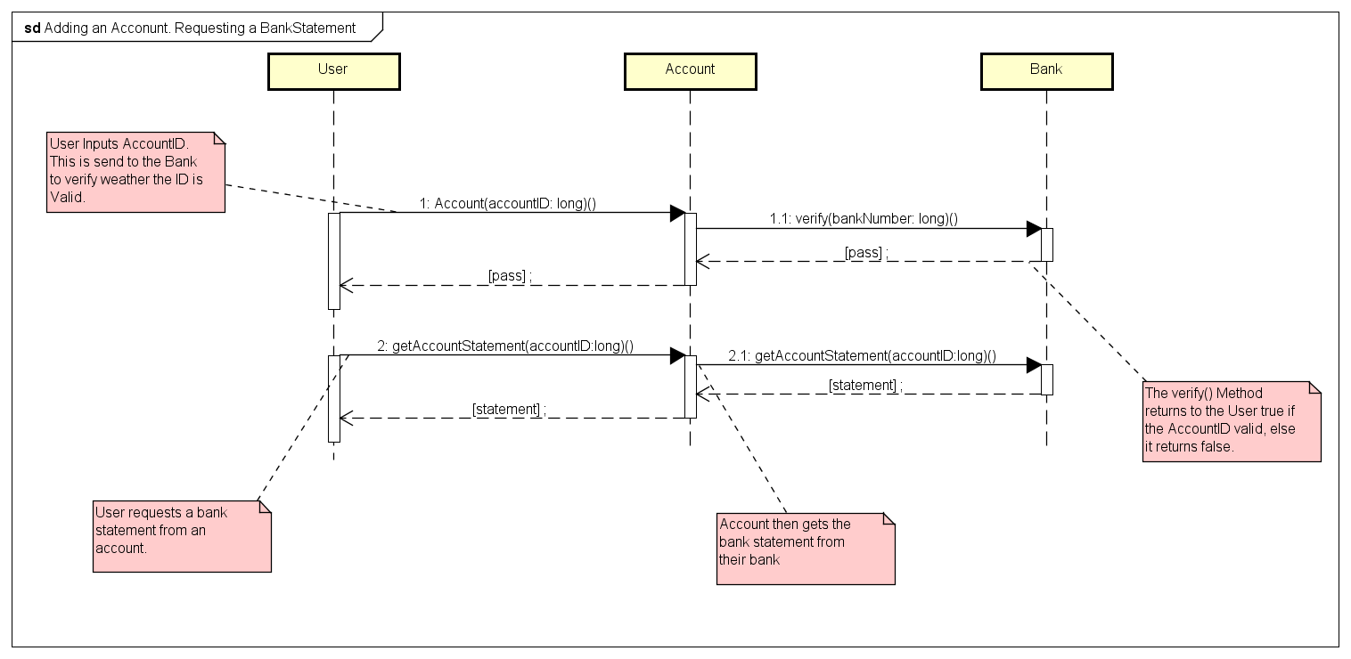
Sequence diagram

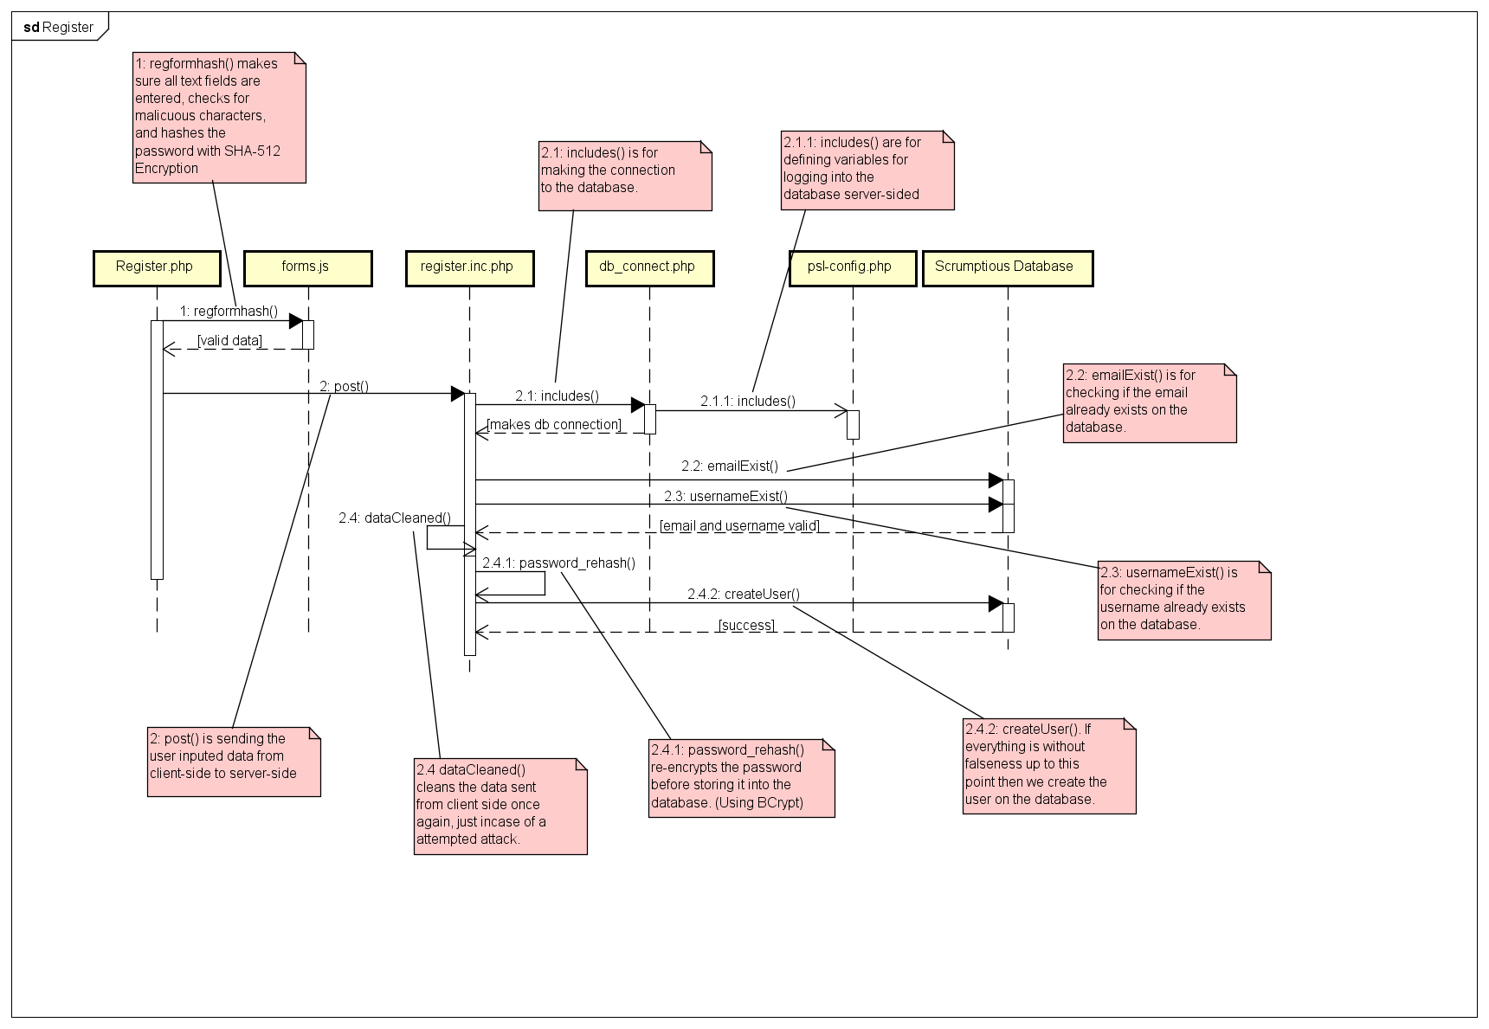
Register User Sequence Diagram

Activity Diagram

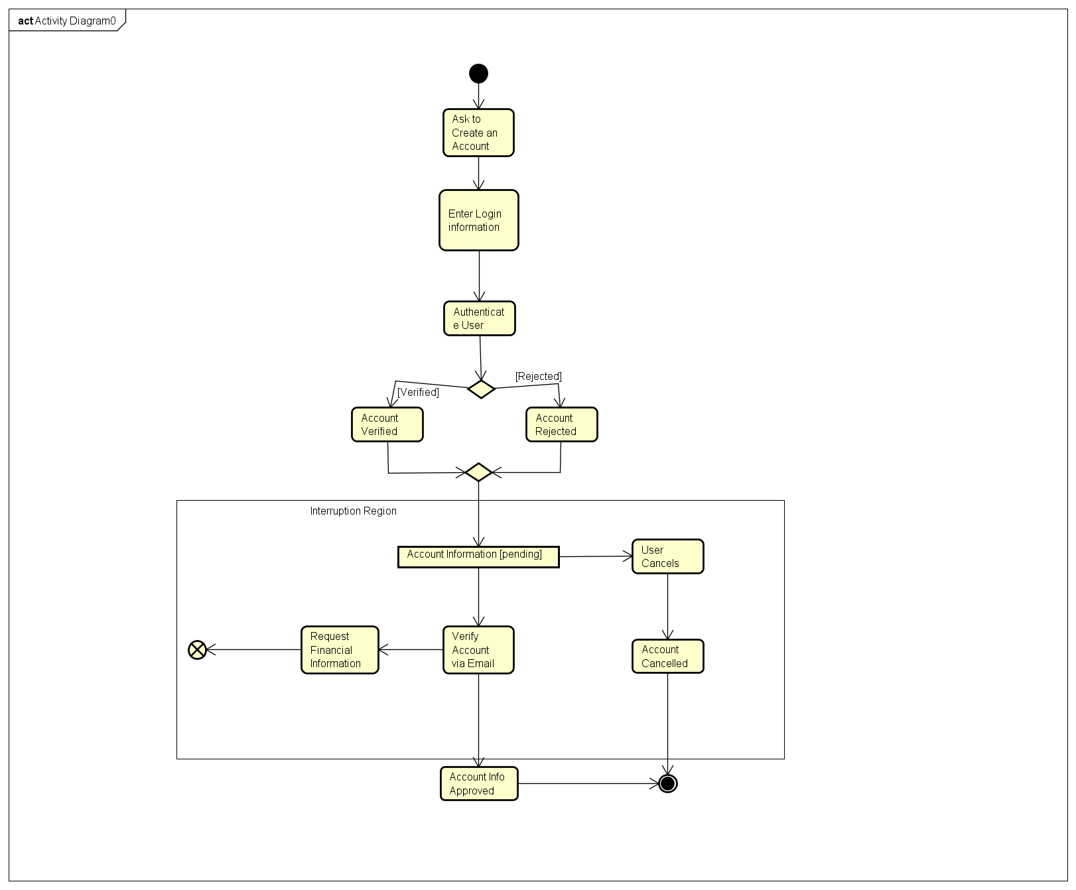

UML Class Diagram
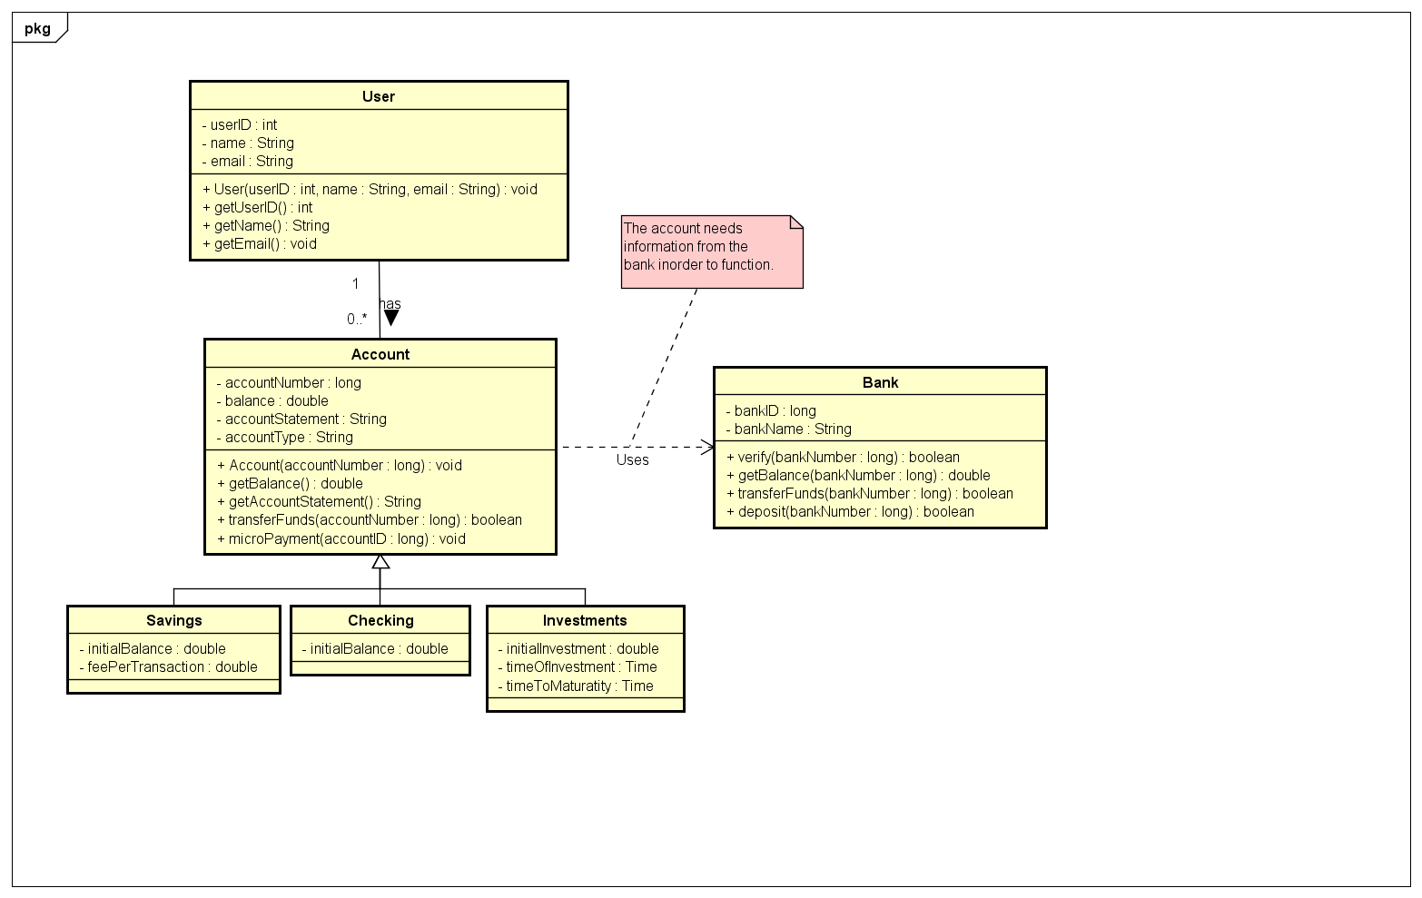

Use Case Diagram

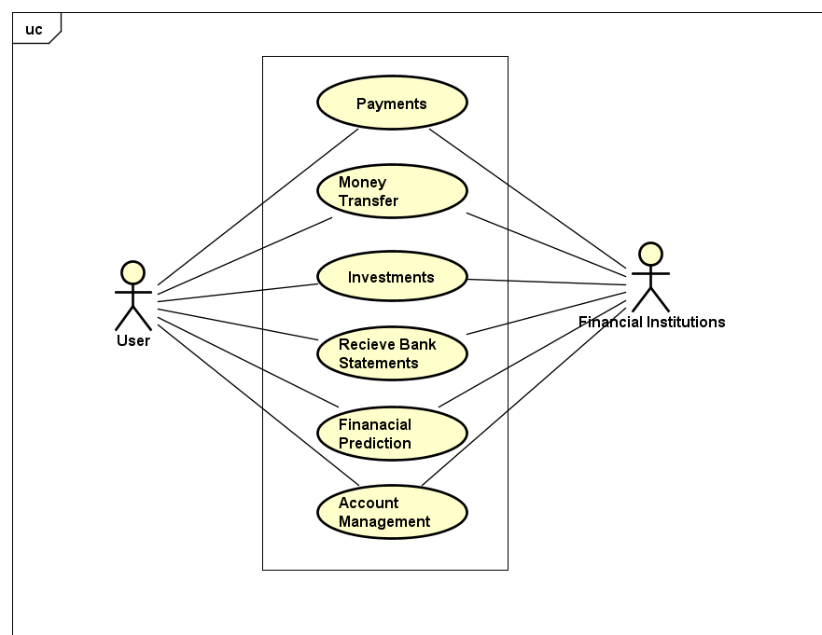

Appendix C: To Be Determined List
- User Interfaces
- Software Interfaces

